1a) viva questions

1️⃣ What is fork()?
Answer:
fork() is a UNIX system call used to create a new process. The newly created process is called the child, and the calling process is the parent.

2️⃣ What is the return value of fork()?
Answer:
- 0 → returned to child process
- >0 → returned to parent process (child PID)
- -1 → process creation failed

3️⃣ How many processes are created by a single fork() call?
Answer:
Two processes are created: one parent and one child.

4)How does the OS differentiate parent and child after fork()?
Answer:
Using the return value of fork():
- pid == 0 → child
- pid > 0 → parent

5️⃣ Do parent and child execute the same program?
Answer:
Yes. Both parent and child execute the same program code, starting from the line after fork().

6️⃣ Is memory shared between parent and child?
Answer:
No. Parent and child have separate memory spaces (logical copy of memory).

7️⃣ What is PID?
Answer:
PID (Process ID) is a unique number assigned to each process by the operating system

8️⃣ What is getpid()?
Answer:
getpid() returns the process ID of the current process.

9️⃣ Why is the output order different each time?
Answer:
Because parent and child processes run concurrently, scheduling depends on the OS.
.

🔟 What happens if fork() fails?
Answer:
It returns -1, and no child process is created.
11)Which header file is required for fork()?
#include <unistd.h>

1️⃣2️⃣ What is pid_t?
Answer:
pid_t is a data type used to store process IDs.

1️⃣3️⃣ Can parent and child have the same PID?
Answer:
❌ No. Each process has a unique PID.

1️⃣4️⃣ In which operating systems is fork() used?
Answer:
fork() is used in UNIX / Linux operating systems.

1️⃣5️⃣ What happens if we write code after fork() without condition?
Answer:
That code will be executed by both parent and child.

1️⃣6️⃣ What is a zombie process?
Answer:
A child process that has terminated but whose parent has not collected its exit status.

1️⃣7️⃣ What system call prevents zombie processes?
Answer:
wait() system call.

1️⃣8️⃣ Can fork() create multiple children?
Answer:
Yes, by calling fork() multiple times.

1️⃣9️⃣ What is the relationship between parent and child?
Answer:
Child is an exact copy of the parent at creation, except for PID.

2️⃣0️⃣ Real-time use of fork()?
Answer:
Used by:
- Shells
- Web servers
- Multitasking systems
1b) wait and exit

1️⃣ What is exit()?
Answer:
It is a system call used to terminate a process and return a status to the parent.

2️⃣ What is wait()?
Answer:
It makes the parent process wait until the child process terminates.

3️⃣ Why is wait() needed?
Answer:
To prevent zombie processes and to collect the child’s exit status.

4️⃣ Which process calls exit()?
Answer:
The child process.

5️⃣ Which process calls wait()?
Answer:
The parent process.

6️⃣ What happens if parent does not call wait()?
Answer:
The child becomes a zombie process.

7️⃣ What is a zombie process?
Answer:
A terminated child process whose exit status is not collected by the parent.

8️⃣ What does wait() return?
Answer:
The PID of the terminated child process.

9️⃣ What header files are required?
Answer:
#include <sys/wait.h>
#include <stdlib.h>

🔟 What is WEXITSTATUS()?
Answer:
It extracts the exit status of the child from status.

1️⃣1️⃣ What happens if child exits before parent calls wait()?
Answer:
Child remains in zombie state until parent calls wait().

1️⃣2️⃣ Can wait() wait for multiple children?
Answer:
Yes, by calling wait() multiple times.

1️⃣3️⃣ Difference between exit() and return?
Answer:
- exit() terminates the process
- return exits a function

1️⃣4️⃣ Real-time use of wait()?
Answer:
Used in shells, servers, and process control programs.
1c) open ,read,write system calls

🔹 IMPORTANT VIVA QUESTIONS on open(), read(), write(), close() System Call Program

Below are most expected, examiner-oriented viva questions based exactly on your program.
Answers are short, clear, and exam-ready ✅

🔹 BASIC CONCEPT QUESTIONS

1️⃣ What are system calls?
Answer:
System calls are interfaces between user programs and the operating system kernel.

2️⃣ Why do we use file system calls?
Answer:
To open, read, write, and close files at the OS level.

3️⃣ What does open() system call do?
Answer:
It opens an existing file or creates a new file and returns a file descriptor.

4️⃣ What is a file descriptor?
Answer:
A non-negative integer that uniquely identifies an open file in a process.

5️⃣ What are the standard file descriptors?
Answer:
- 0 → stdin
- 1 → stdout
- 2 → stderr

🔹 QUESTIONS ON open() PARAMETERS

6️⃣ What is pathname?
Answer:
It specifies the name or path of the file.

7️⃣ What are flags in open()?
Answer:
They specify how the file is opened (read/write/create).

8️⃣ Name some common open() flags.
Answer:
O_RDONLY, O_WRONLY, O_RDWR, O_CREAT, O_APPEND.

9️⃣ What is mode in open()?
Answer:
It specifies file permissions and is used only with O_CREAT.

🔟 What does 0644 mean?
Answer:
Owner: read & write; Group and others: read only.

🔹 QUESTIONS ON read() & write()

1️⃣1️⃣ What does read() do?
Answer:
Reads data from a file into a buffer.

1️⃣2️⃣ What does write() do?
Answer:
Writes data from a buffer into a file.

1️⃣3️⃣ What does read() return?
Answer:
Number of bytes read or 0 on EOF.

1️⃣4️⃣ What does write() return?
Answer:
Number of bytes written.

1️⃣5️⃣ Why is buffer needed?
Answer:
To temporarily store data read from the file.

🔹 QUESTIONS ON close()

1️⃣6️⃣ What does close() do?
Answer:
Closes the file and releases system resources.

1️⃣7️⃣ What happens if we don’t close a file?
Answer:
It causes resource leakage.

🔹 COMPARISON & CONCEPTUAL QUESTIONS

1️⃣8️⃣ Difference between open() and fopen()?
Answer:
- open() → system call, uses file descriptor
- fopen() → library function, uses FILE pointer

1️⃣9️⃣ Why are system calls faster?
Answer:
They directly interact with the kernel.

2️⃣0️⃣ What happens if open() fails?
Answer:
It returns -1.

🔹 MOST IMPORTANT EXAM QUESTIONS ⭐

2️⃣1️⃣ Why is lseek() used in the program?
Answer:
To move the file pointer to the beginning before reading.

2️⃣2️⃣ What happens if O_CREAT is not used?
Answer:
File must already exist, or open() fails.

2️⃣3️⃣ Can read() and write() work without open()?
Answer:
❌ No.

2️⃣4️⃣ What type of OS supports these system calls?
Answer:
UNIX / Linux operating systems.

2️⃣5️⃣ Give one real-time example.
Answer:
Used in text editors, file copy commands, and OS utilities.

🔹 TOP 5 MUST-REMEMBER VIVA QUESTIONS 🚨
- What is a file descriptor?
- Explain parameters of open()
- What does 0644 mean?
- Difference between open() and fopen()
- Why is close() necessary?

🔹 ONE-LINE PERFECT VIVA ANSWER ✨
open() opens a file and returns a file descriptor, read() reads data, write() writes data, and close() releases resources.
2)What happens if wait() is not used?
Short, clear exam answer:
If wait() is not used, the parent process does not wait for the child process to finish. The child may continue running after the parent exits, which can lead to a zombie process.

🔹 Detailed but easy explanation (for viva)
- When a child process finishes execution, it sends its exit status to the parent.
- If the parent does not call wait(), it never collects this exit status.
- The child process becomes a zombie process (terminated but still listed in the process table).
- Zombie processes waste system resources.
- The execution order of parent and child becomes unpredictable.

🔹 What is a Zombie Process?
- A process that has finished execution
- But still exists in the process table
- Because the parent did not call wait()

❓ Why is exec() used? (Short & To the Point)
exec() is used to replace the current process with a new program.

✅ Key Points (Perfect for Viva / Exam)
- exec() loads and runs a new program
- It replaces the current process code
- Process ID (PID remains the same)
- Used after fork() to run a different program in the child
- The old program does not continue after exec()

🔹 One-Line Exam Answer
exec() is used to replace the current process with a new program without creating a new process.

🔹 Simple Example (Conceptual)
- fork() → creates a child process
- exec() → child runs a new program

🔹 Very Short Viva Q&A
- Does exec() create a new process?
❌ No
- Does PID change after exec()?
❌ No
- Why use fork() + exec() together?
✔ To create a process and run a different program
3)threads and multithreading
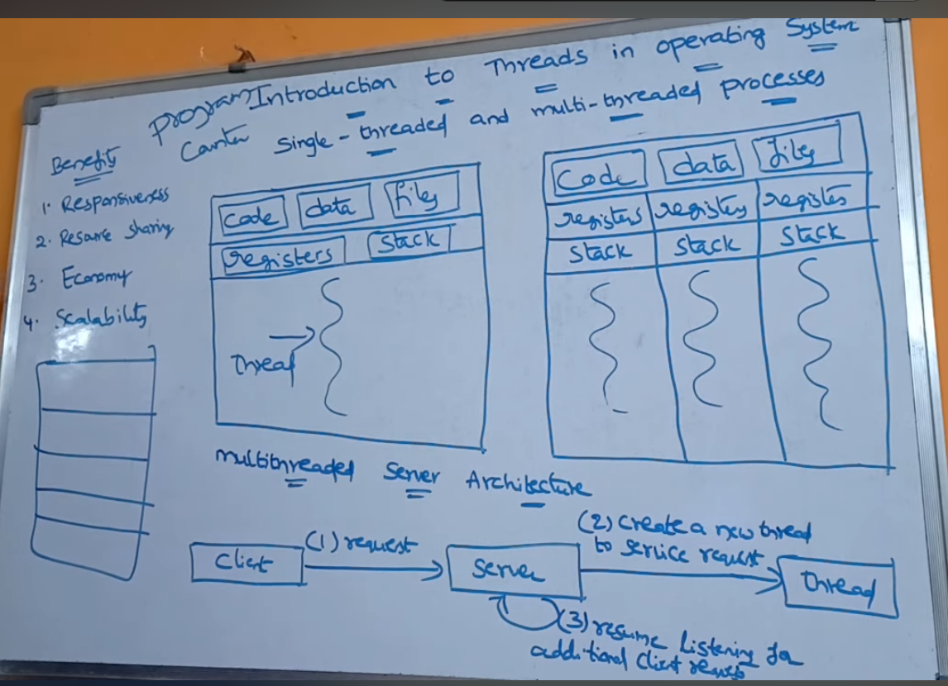

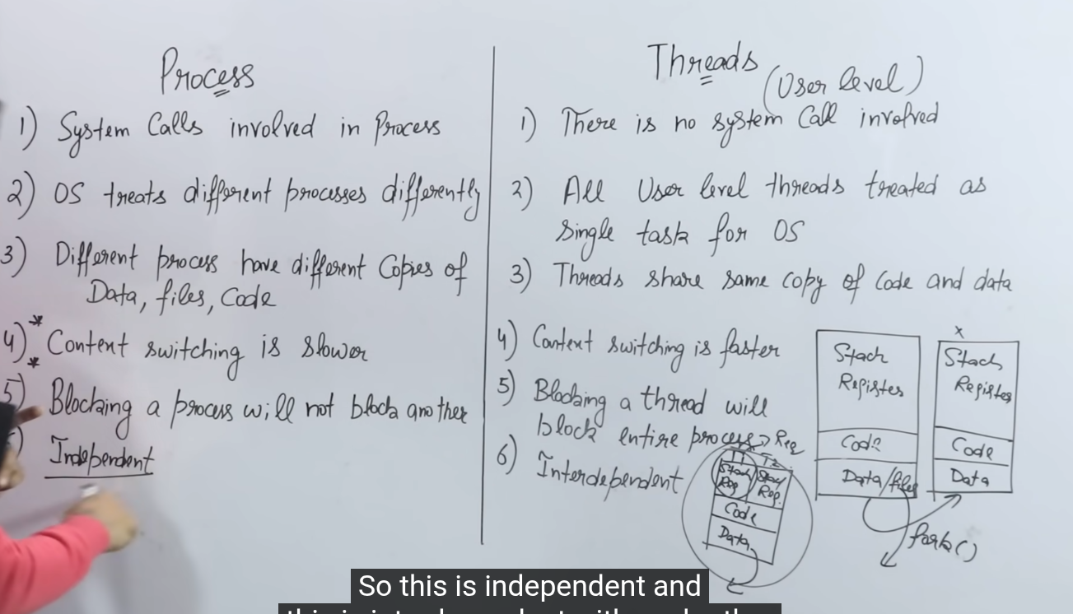

4)scheduling algorithms

1. What is CPU scheduling?
CPU scheduling is the process of selecting one process from the ready queue to allocate the CPU.

2. Why is CPU scheduling required?
To maximize CPU utilization, reduce waiting time, and improve system performance.

3. What are the scheduling criteria?
- CPU utilization
- Throughput
- Waiting time
- Turnaround time
- Response time

4. What is waiting time?
Waiting time is the total time a process waits in the ready queue before execution.

5. What is turnaround time?
Turnaround time is the total time from process arrival to completion.
Formula:
TAT = Completion Time – Arrival Time

6. Difference between preemptive and non-preemptive scheduling?
Preemptive | Non-Preemptive
CPU can be taken back | CPU not taken back
More overhead | Less overhead
Example: RR | Example: FCFS

🔹 FCFS (FIRST COME FIRST SERVE) – VIVA

7. What is FCFS scheduling?
FCFS executes processes in the order of their arrival.

8. Is FCFS preemptive or non-preemptive?
👉 Non-preemptive

9. What is the main advantage of FCFS?
- Simple to implement
- No starvation

10. What is the main disadvantage of FCFS?
👉 Convoy Effect
A long process delays all short processes.

11. What is convoy effect?
When a long process occupies the CPU, all other short processes must wait.

12. Where is FCFS used?
- Batch systems
- Simple systems

13. Does FCFS give minimum waiting time?
❌ No

🔹 SJF (SHORTEST JOB FIRST) – VIVA

14. What is SJF scheduling?
SJF selects the process with the smallest burst time first.

15. Is SJF preemptive or non-preemptive?
👉 Can be both
- Non-preemptive → SJF
- Preemptive → SRTF

16. What is the main advantage of SJF?
👉 Minimum average waiting time

17. What is the major problem of SJF?
👉 Starvation
Long processes may never execute.

18. Why is SJF difficult to implement?
Because burst time is not known in advance.

19. What is starvation?
A process waits indefinitely because shorter processes keep getting executed.

20. How can starvation be solved?
By aging technique.

21. Is SJF optimal?
✔ Yes, for minimizing average waiting time.

🔹 ROUND ROBIN (RR) – VIVA

22. What is Round Robin scheduling?
Each process gets CPU for a fixed time quantum in cyclic order.

23. Is Round Robin preemptive?
✔ Yes

24. What is time quantum?
Time quantum is the fixed amount of CPU time given to each process.

25. What happens if time quantum is very large?
👉 RR behaves like FCFS

26. What happens if time quantum is very small?
👉 Too many context switches

27. Main advantage of Round Robin?
- No starvation
- Fair CPU allocation

28. Main disadvantage of Round Robin?
- High context switching overhead

29. Where is Round Robin used?
- Time-sharing systems
- Multi-user systems

30. Which scheduling algorithm is best for interactive systems?
👉 Round Robin

🔹 COMPARISON VIVA QUESTIONS (VERY IMPORTANT)

31. FCFS vs SJF vs Round Robin
Feature | FCFS | SJF | RR
Preemptive | ❌ | ❌ / ✔ | ✔
Starvation | ❌ | ✔ | ❌
Fairness | ❌ | ❌ | ✔
Complexity | Low | Medium | Medium
Best Use | Batch | Optimized systems | Time sharing

32. Which algorithm gives minimum average waiting time?
👉 SJF

33. Which algorithm is simplest?
👉 FCFS

34. Which algorithm is most fair?
👉 Round Robin
35. Which algorithm avoids starvation?
👉 FCFS & Round Robin

🎯 FINAL EXAM TIP (VERY IMPORTANT)
If examiner asks:
“Explain in one line”
Use these:
- FCFS → Executes processes in arrival order
- SJF → Executes shortest job first
- RR → Time-sliced cyclic execution
5)producer consumer problem
🔥 TOP 15 PRODUCER–CONSUMER VIVA QUESTIONS
(Concept-oriented • Tricky • Examiner-favorite)

1️⃣ Why is Producer–Consumer considered a classical synchronization problem?
Answer:
Because it clearly demonstrates the need for synchronization, mutual exclusion, and coordination between concurrent processes sharing a common resource.

2️⃣ What is the core OS problem being solved in Producer–Consumer?
Answer:
Safe access to shared resources while preventing race conditions and maintaining data consistency.

3️⃣ What exactly is the critical section in Producer–Consumer?
Answer:
The code segment where the shared buffer is accessed or modified by producer or consumer.

4️⃣ Why can’t Producer and Consumer run independently without synchronization?
Answer:
Because unsynchronized access leads to data inconsistency, overwriting of data, or invalid consumption.

5️⃣ What hidden role do semaphores play in Producer–Consumer?
Answer:
They control execution order, enforce mutual exclusion, and ensure correct timing between producer and consumer.

6️⃣ Why are two different semaphores (empty and full) required?
Answer:
To separately track:
- Available buffer slots (empty)
- Filled buffer slots (full)
Using one semaphore is insufficient.

7️⃣ What will happen if mutex is removed but other semaphores are used?
Answer:
Race condition will still occur because mutual exclusion is not guaranteed.

8️⃣ Can Producer–Consumer lead to deadlock? When?
Answer:
Yes, if semaphores are acquired in the wrong order or released incorrectly.

9️⃣ How is Producer–Consumer different from busy waiting?
Answer:
Proper implementation uses blocking mechanisms, not CPU-wasting busy loops.

🔟 Why is Producer–Consumer NOT just a memory problem?
Answer:
Because it involves process scheduling, synchronization, and coordination, not just data storage.

1️⃣1️⃣ What OS layer is mainly involved in solving Producer–Consumer?
Answer:
The process synchronization and IPC (Inter-Process Communication) layer of the OS.

1️⃣2️⃣ Why is Producer–Consumer important in real operating systems?
Answer:
It models real scenarios like:
- I/O buffering
- Printer spooling
- Network packet handling

1️⃣3️⃣ What is the difference between logical correctness and synchronization correctness in this problem?
Answer:
- Logical correctness → program logic works
- Synchronization correctness → program works under concurrent execution

1️⃣4️⃣ Can Producer–Consumer be solved without semaphores?
Answer:
Yes, using:
- Mutex locks
- Monitors
- Condition variables
But semaphores are the most fundamental.

1️⃣5️⃣ Which three OS concepts are implicitly tested by this problem?
Answer:
- Mutual exclusion
- Process synchronization
- Deadlock avoidance

